My IP address is 192.168.200.8

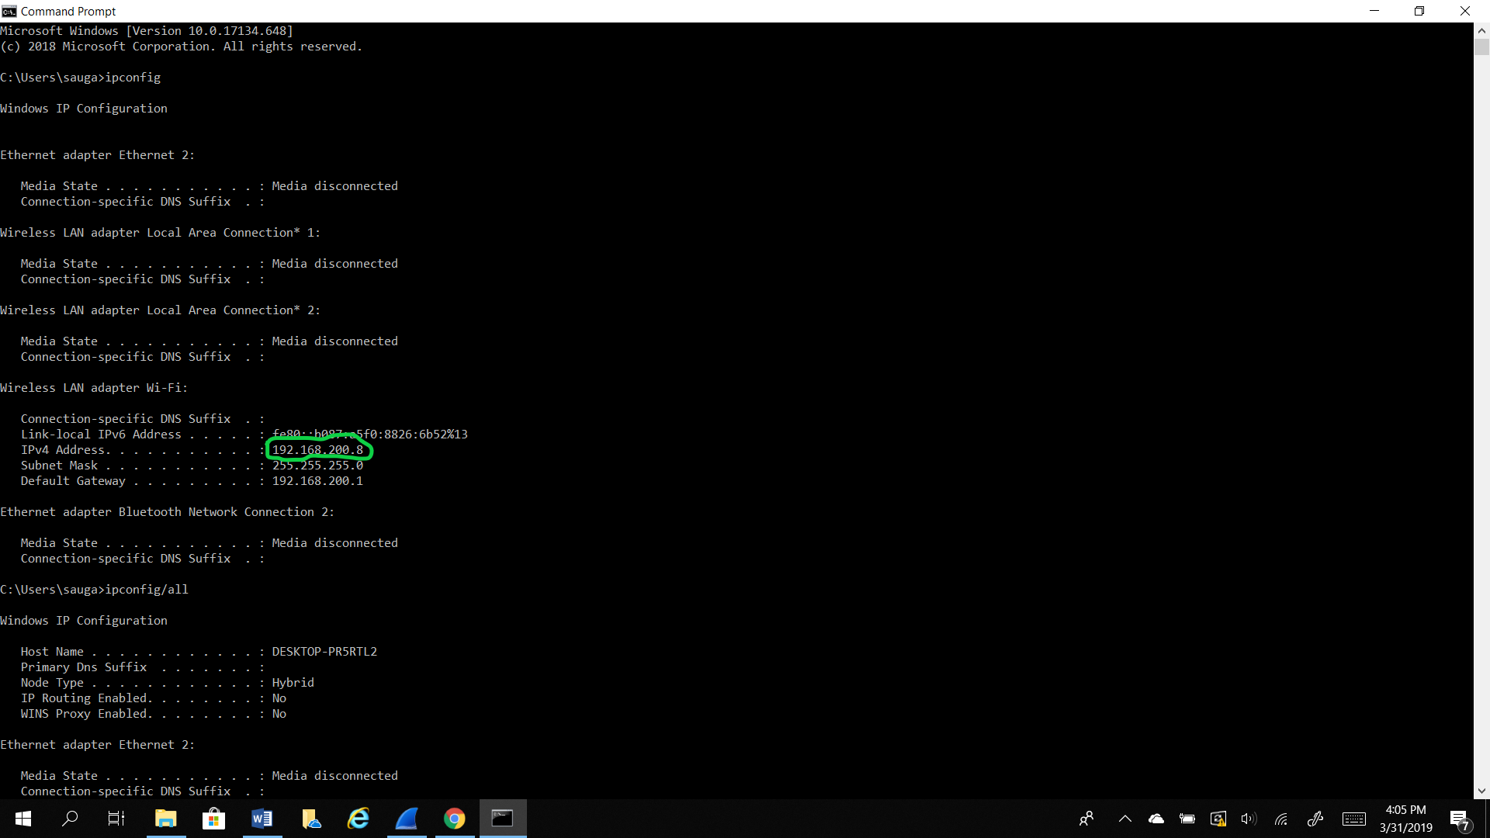

1. The MAC address from my computer is (ac:ed:5c:47:b8:32)

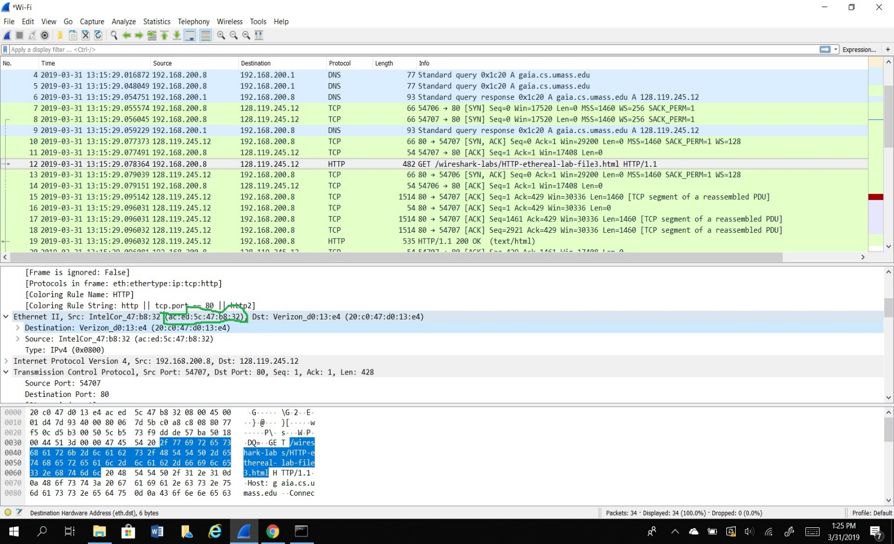

1. The destination MAC address is (20:c0:47:d0:13:e4)

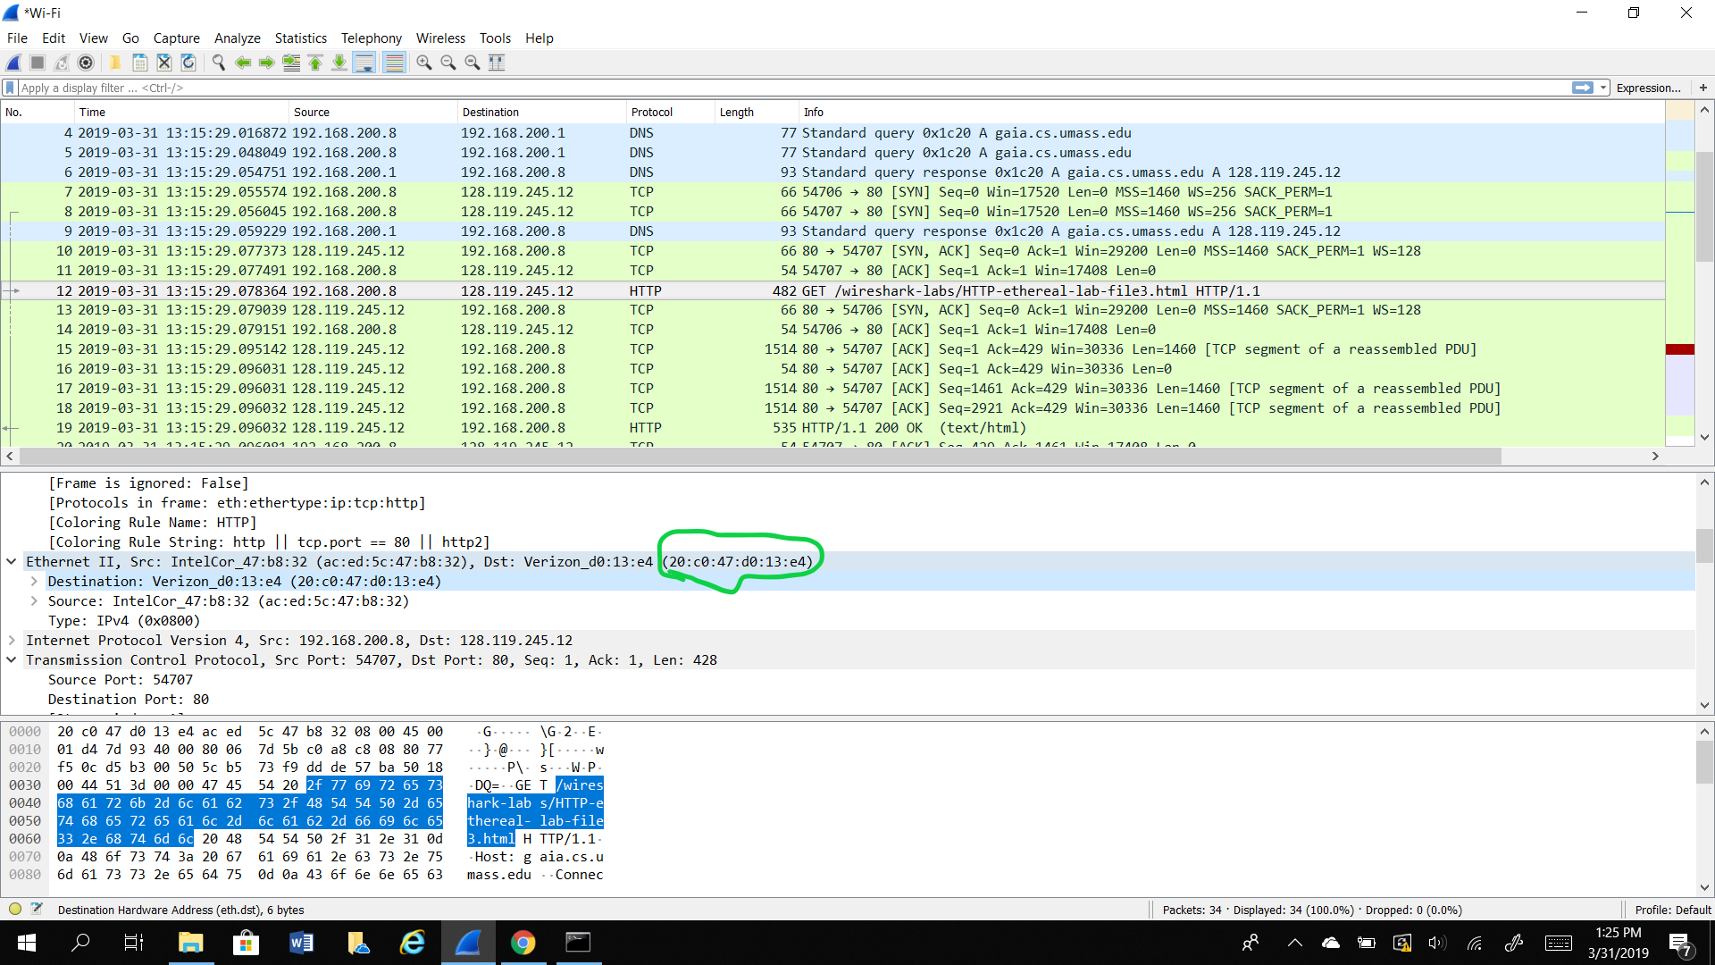

1. The MAC address has show: Verizon_d0:13:e4 in the destination.

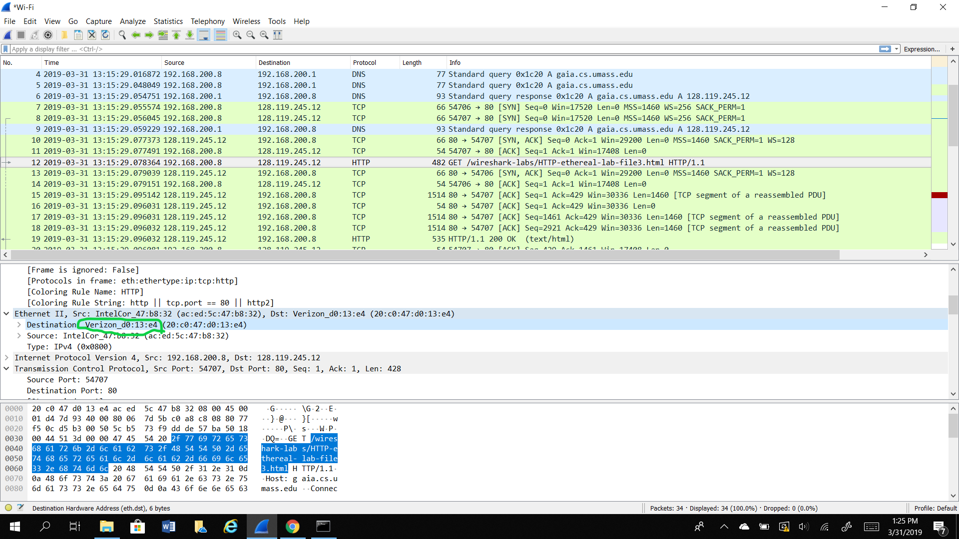

1. The MAC address is a layer 2 address and the IP address is a layer 3 address. So the relationship between the destination MAC address and the destination IP address is that the destination IP address is the final destination address of the website and the destination MAC address is the physical address of my router. These together are used to create and send datagrams. ARP takes these data through an IP address to an actual piece of computer hardware.

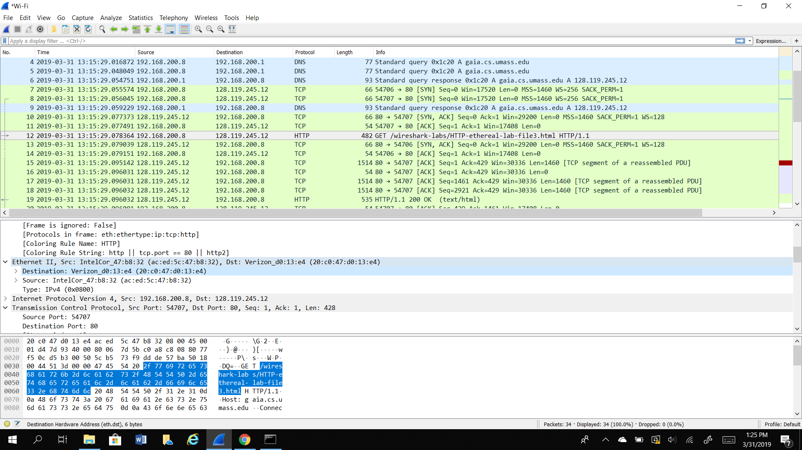

1. ARP list table.

